UNIVERSIDAD METROPOLITANA DE CIENCIAS DE LA EDUCACIÓN
FACULTAD DE HISTORIA, GEOGRAFÍA Y LETRAS.
DEPARTAMENTO DE INGLÉS
MAGÍSTER EN LA ENSEÑANZA-APRENDIZAJE DEL INGLÉS COMO LENGUA EXTRANJERA (TEFL)



USING GOOGLE PLUS AS A TOOL IN THE IMPROVEMENT OF LISTENING COMPREHENSION IN THE EFL CLASS

TESIS PARA OPTAR AL GRADO DE MAGÍSTER EN LA ENSEÑANZA-APRENDIZAJE DEL INGLÉS COMO LENGUA EXTRANJERA (TEFL)

AUTORA: DENISSE ROJAS JERIA
PROFESOR GUÍA: EDWIN ABBETT

SANTIAGO DE CHILE, MARZO DE 2015

ACKNOWLEDGEMENTS

I would like to express my deepest gratitude to all those people who made this thesis possible and an unforgettable experience for me. First and foremost I would like to express my sincere gratitude to my advisor Prof. Edwin Abbett who has supported me throughout this thesis with his expertise and patience. His guidance helped me in all time of the study without him it, too, would not have been written. I could not have imagined wishing a better advisor for my Master degree.

I would also like to thank my fiancé Alfredo for the support he provided me through the difficult times we lived together. Despite his illness he was always there cheering me up and stood by me through the good and bad times. Thank you for support me at all times, especially in moments of difficulty and stress.

I am most grateful to my mother-in-law whose guidance, caring and patience provides me excellent ideas to develop during and after the study. I thank my friends who were always supporting me and encouraging me with their best wishes. My sincere thanks must also go to my dear students who were the protagonists and contribute in this dissertation. Without their generous participation this would not have been possible.

Last but not the least I would like to express the profound gratitude from my deep heart to my beloved parents, my siblings and my niece for their love and continuous support (spiritually and materially) through my entire life without them I would not have finished this thesis.

TABLE OF CONTENTS
Page n°
ACKNOWLEDGEMENTS……………………………………………………… iii
TABLE OF CONTENTS………………………………………………………….iv
ABSTRACT……………………………………………………………………….vi
- INTRODUCTION………………………………………………………...1
- PURPOSE OF STUDY……………………………………………………3
- LITERATURE REVIEW………………………………………………… 5
3.1 Listening and Listening Comprehension…………………………………...5
3.2 Teaching Listening for Comprehension…………………………………… 7
3.3 ICT in the Classroom……………………………………………………… 11
3.4 ICT in Foreign Language Learning……………………………………….. 14
3.5 Google plus as an application in the Language Learning Classroom…….. 15
- RESEARCH QUESTIONS AND HYPOTHESIS……………………….. 18
- METHODOLOGY………………………………………………………. 19
5.1 Sampling……………………………………………………………………19
  - Participants and Structure………………………………………………… 20
- DATA COLLECTION AND ANALYSIS………………………………… 21
6.1 Instruments……………………………………………………………….... 22

- DATA ANALYSIS………………………………………………………… 24
7.1 Validity and reliability ……………………………………………………...25
- RESULTS AND DISCUSSION…………………………………………..26
  - Overall Analysis of the session classes Group A.……………………….... 35
8.2 Overall Analysis of the session classes Group B………………………… 37
- CONCLUSIONS……………………………………………………………40
- REFERENCES……………………………………………………………...44
APPENDICES
APPENDIX A: Listening Comprehension Rubric……………………………….. 51
APPENDIX B: Listening pre- and post-tests…………………………………….. 52
APPENDIX C: Table showing the difficulty level of the tasks in both
Groups A and B……………………………………………………55
APPENDIX D: Table showing students’ performance in the pre-test……………56
APPENDIX E: Table showing a comparison of students’ progress
in the pre- and post- tests…………………………………………..57
APPENDIX F: Google Plus platform: Class Community………………………...58
APPENDIX G: Lesson plans Group A…………………………………………… 61
APPENDIX H: Lesson plans Group B…………………………………………… 66

ABSTRACT

Listening is an essential skill for learning English language. It plays a significant role in communication due to the fact that it adopts all the rules of the language and facilitates the emergence of other skills such as speaking, reading and writing. Listening can be also described as a complex process that in native speakers, listening skills are not always fully developed. Hence, it seems reasonable to say that English teachers ought pay more attention to develop this skill effectively through practice using activities that are interesting for the students. Therefore, teachers need to select the material carefully and provide students real life contexts as Ur (1984) explained sound recordings and telephone conversations only comprise small part of improving listening skills. Thus, environmental clues also contribute valuable information to understanding the language by the interlocutors’ facial expressions and movements. In developing listening comprehension, this dissertation incorporates a creative ICT tool that enhances students’ listening skills. This study aims to measure whether or not Google Plus can improve listening comprehension in a sample of 40 students taken randomly, they were in 11th grade in Piamarta School. A listening test served as pre- and post-test as well as several listening tasks were provided in order to collect data. Finally, the present study offers some pedagogical suggestions for further investigations.

Key words: listening comprehension, ICTs, Google Plus.

RESUMEN

La habilidad de escuchar es esencial para aprender el idioma Inglés, juega un rol importante dentro de la comunicación ya que adopta reglas de la lengua que facilita el surgimiento de otras habilidades tales como hablar, leer y escribir. El escuchar también puede ser descrito como un proceso complejo incluso para los hablantes nativos quienes no siempre logran desarrollarlo completamente. Por consiguiente, parece razonable suponer que los(as) profesores(as) debieran prestar más atención en desarrollar esta habilidad de manera efectiva mediante practica utilizando actividades interesantes para los estudiantes. Por lo tanto, los(as) profesores(as) necesitan seleccionar el material cuidadosamente y proporcionar situaciones reales como Ur (1984) explica que las grabaciones y conversaciones telefónicas sólo compromete una pequeña parte en la mejora de las habilidades de escuchar. De este modo, las claves del entorno contribuyen una información valiosa para comprender el idioma a través de las expresiones faciales y movimientos corporales de los interlocutores. Para el desarrollo de la comprensión auditiva, este estudio incorpora una herramienta TIC creativa que mejore las habilidades de audición de los estudiantes. Este estudio propone evaluar si Google Plus desarrolla la habilidad de comprensión auditiva en una muestra de 40 estudiantes escogidos al azar del colegio Piamarta. Una prueba de comprensión auditiva servirá como pre- y post- test, como además, varias tareas que ayudaran a la recolección de datos. Finalmente, el presente estudio ofrece algunas sugerencias pedagógicas para futuras investigaciones.

Palabras claves: comprensión auditiva, TIC, Google Plus.

- INTRODUCTION

Since the spread of computers in the 1980’s, Information Communication Technology ICT has brought relevant advances to the EFL classroom. The use of new technological platforms of information and communication has brought more powerful and improved tools to the service of education. For instance, ICTs help students feel familiarized with English pronunciation and it also provides them real life contexts through TV programs, movies, videos (Warschauer, 1997).

Listening in a foreign language is a complex skill that needs to be improved through practice using activities that are interesting for the students. Listening plays a significant role in a classroom because it is essential to develop other language skills. According to Petrie (1961), listening comprehension is used more than any other way of verbal communication, primarily in the classroom. Therefore, teaching and learning listening skills is essential for successful communication “A child learns to speak by listening to their parents; he learns to read listening to them and to their teachers. When he makes a mistake of pronunciation, spelling or understanding, he probably will have to listen to criticism from a teacher, a parent or a friend, in order to learn of his mistake” (Remo & Mc Glone, 1972, p. 79). Indeed, the national curriculum suggests some methodological considerations for teaching foreign language. It states that the learning of a second language is based mainly on the development of the receptive skills. This methodology integrates prior knowledge and students’ experience in their mother tongue and the target language (Ministerio de Educación, 2004)
To be successful, students of English language need to be exposed to the language several times before they can recognize and pronounce the words. For instance, Nunan (1998) believes that "listening is the basic skill in language learning. Without listening skill, learners will never learn to communicate effectively” (p.1). However, students from environments where English as a foreign language (EFL) is only taught as a subject at school and used inside, but not outside the classroom. Consequently, students have very few opportunities to hear the language in its natural setting. As English teachers, it is important to bear in mind the aspects that Ur describes in her book about grading listening which are: (1) the type of input; (2) the support provided by the listening context; and (3) the kind of task involved (Ur, 1984). These are included in the design of the sessions given during the study.

As technology has gained importance in our society and has become much more important in the educational system, ICT teaching-learning has been selected to develop in an integrated manner. Furthermore, students can combine different tasks in order to improve their skills in the foreign language, specially listening comprehension. That is why in this study the support of listening context is provided through the use of an ICT as a useful tool as teachers to improve students’ listening comprehension.

The present study plans to focus on the use of Google Plus to improve listening comprehension. This suggested application consists various types of content, such as text, audio, video, graphics, animation, and interactivity so students have access to a broad range of information, knowledge, ideas, and opinions well beyond their classroom.

Thus, by means of this dissertation we come to the main purpose of this investigation. It aims to answer the following research questions: What skills does the current curriculum framework promote in our schools? To what extent are ICTs used for improvements in listening comprehension in Chilean schools? Is students’ listening comprehension made more effective by using an ICT tool? and Do students improve their listening ability to identify general and specific information by using different types of texts such as television programs, video programs, and podcasts?

- PURPOSE OF STUDY

Adolescents deal with technology on a daily basis and spend their time in their mobile phones or computers which offer facilities beyond different applications with which they are already familiar and which they use to chat with their friends, upload photos and watch musical videos. Thus, the role played by Information Communication Technologies (ICTs) in education has come under close scrutiny in recent years from researchers. Among others, Garret (2009) has described that people not only have access to computers but also a wide range of digital tools which could be used to support teaching and learning languages. Technology has been discussed in terms of the benefits that can bring to education. Not only does it allow students to be part of their education process but it also provides an instrument called the Internet which brings numerous advantages such as the connection with other people providing a real world inside the classroom. Additionally, technology is integrated into the Chilean curriculum in order to enhance learning in education. There is even a national high-stakes test called SIMCE TIC which is applied in the 10th grades.

Similarly, teachers need to look for better ways of encouraging students to be involved in their learning process. Listening is the most arduous and essential skill in a foreign language it adopts all the rules of the language and facilitates the emergence of other skills such as speaking, reading and writing (see Dunkel, 1991; Rost, 2002; Vandergrift, 2007). Therefore, it is important to use and create “authentic material” which can be an approximation to the real world. This material needs to be adapted for classroom use but teachers have to be careful in its selection because sometimes the language speed is often difficult to follow so the learner can feel frustrated. It seems to be more useful and practical to provide students visual aids or videos in order to understand the language by the interlocutors’ facial expressions and movements (Ur, 1984). Digital tools offer new opportunities to create authentic materials by designing a variety of tasks to enhance listening skills. Despite the controversy that it entails a daunting amount of timing and planning, teachers should not ignore the fact we live in a technological era, and our students are visual learners so teachers need technical preparation to integrate ICTs inside the classroom in order to feel comfortable when they decide on the type of material they will use. This study intends to measure whether or not ICTs improve listening skills in 11th grade students of Piamarta School since they had to take English SIMCE Test which assesses reading and listening abilities. To carry out this investigation, the arena of literature will be about the definition of listening, the process of listening comprehension and its strategies and the use of ICT in education. A valid and reliable teacher-made listening test served as pre- and post-tests and listening tasks were adopted to collect the necessary data. Based on the results of data collection, this study provided some suggestions and pedagogical implications regarding students’ improvement in their listening skills through the use of Google Plus. This dissertation can be of significance to further investigations, and it may help EFL teachers to integrate ICTs in their lesson plans in order to improve EFL students’ listening comprehension skill.

- LITERATURE REVIEW

Because of the lack of research which has specifically addressed the use of an ICT in the second language listening comprehension processes, the aim of this section is to first examine previous research in the process of listening and make reference some to listening strategies to establish a basis on which to ground the investigation. There are five main aspects will be outlined: listening comprehension, teaching listening, ICT in the classroom, ICT in the foreign language learning, and the use of a Google Application in the EFL classroom.

3.1 Listening and Listening Comprehension.

As far as a definition for listening is concerned, there are a variety of conceptions that define this language skill. Córdova, Coto and Ramírez (2005) indicate that it is impossible to propose one definition of listening. It is not easy to find a universal definition of listening there are several definitions that represent what listening is. However, such definitions provide disagreement among the authors about which of them is the best perspective that describes listening.

Glenn (1989) analyzed fifty definitions of “listening” and found that the elements frequently used in the definitions were perception, attention, interpretation, memories and response. Consequently, Glenn’s study in the International Listening Association journal (1996) has developed a definition of listening as “the process of receiving, meaning construction from, and answering to spoken and/or nonverbal messages”. Yet, there are some definitions that still incorporate new specifications about the concept of listening. Rost (2002) also provides a definition of listening as a process in which first listeners construct and represent the information received from the speaker. Then, in a collaborative way, the speaker and the listener negotiate the meaning and they respond interactively through involvement, imagination, and empathy. In order to develop listening comprehension, the listeners must be able to decode the message and to answer what is said in different ways, for instance, follow commands given by the teacher, in that way they do not have to respond orally if they are not ready (see Asher’s Total Physical Response, 1982), or they can write specific information depending on the purpose of the language.

Listening comprehension consists of the ability to identify and understand the information given by the speakers, i.e. it is a complex process in which students should be able to understand speech in a foreign language. This skill is one the most important areas in language learning, it is the means to facilitate the initial contact of children with the language and its culture (Curtain and Pesola, 1988). If we go back to the early years of human development we can say that children learn to speak once they retain information by hearing their parents talk. So, foreign language learners are exposed to the target language before they will be asked to produce it. This stage of the language acquisition process is called “The Silent Period”in which students behave in passive way just listening to the foreign language without expressing ideas, this period may be shorter or longer it will depend on many variables that come into play. Even after learners develop receptive vocabulary, and understand the syntax or semantics of the language they will be able to understand the target language. If serious problems emerge with the linguistic production learners will be unwilling to understand the language therefore to communicate orally (Anderson and Lynch, 1988). Comprehension precedes production in a natural process. Children will be able to “understand more than they can produce” (Asher, 1977, pp. 54-56). In other words, at the level of comprehension children may manage to understand the language, however, at the level of production they may be unable to utter a single word.

Based on the information above, listening is the means by which other language skills are developed. The Chilean curriculum is focused on the improvement of the receptive skills since the national English SIMCE test assess reading and listening in 11th grade students. The information that this test provides can be valuable to take decisions in teaching strategies in order to enhance listening comprehension. This study aims to introduce listening strategies so as to help students to develop their skills actively (Richards, 2005, p. 2). Therefore, it is suggested to explore an effective manner of teaching the foreign language to upgrade students’ listening comprehension.

3.2 Teaching Listening for Comprehension

Throughout history, listening has been poorly practiced in the English language classroom. This could be due to fact that the productive skills were given more attention rather than receptive skills and teachers believed that listening was taught merely by exposing students to spoken language (Nunan, 1993).

There are several reasons to teach listening. According to Harmer (1998) an important reason is “to help students to acquire language subconsciously even if teachers do not draw attention to its special features” and “a second major reason for getting students to listen to spoken language is to let them hear different varieties and accents” (p. 98)

The curriculum for English study at the 11th grade indicates that students should be exposed to English environments using different methods such as dialogues, poems, videos, songs in order to repeat and imitate the sounds (Ministerio de Educación, 2004).

It is essential to bear in mind the methods used and the type of materials prepared for students. In the opinion of this researcher, teachers should provide students activities resemble real-life contexts in which learners will be able to do when using the language outside the classroom. This refers to introducing authentic materials in order to bridge the gap between the real world and the classroom. Those authentic activities will be given to students so as to “…practice in the classroom the sort of skilled behavior they might be expected to display in genuine communicative interaction outside the classroom” (Nunan, 1989, p. 59).

An important aim in teaching listening by using authentic listening tasks is the use of strategies that will help students to understand the processes. It is very important for teaching listening that students use prior knowledge and connect it with the new information in order to improve their comprehension. There are activities that can be taught both “bottom-up” and “top-down”, they both play important roles in listening (Nunan, 1993).

The “bottom-up” processing model (BUP) refers to the form and structure of the language: students’ attention relies on the language in order to focus on specific information. The listener decodes the sounds that one hears in a linear fashion from the smallest meaningful units to a whole text. Then these units are decoded and linked together to form words, and words are linked together to form phrases, phrases are linked together to form utterances, and finally utterances are linked together to form complete texts (Nunan, 1993).

Therefore “bottom-up” processing requires that the listener use linguistic knowledge to assemble their understanding of what they hear one step at a time. The process of listening comprehension underlines any aural messages and listener’s lexical and grammatical competence in a language in order to facilitate some bottom-up processing (Anderson and Lynch, 1988). These authors in their book on listening contrast this view as a “listener as tape recorder” because this suggests that the listener takes in and stores in a similar way as a tape recorder. Students need bottom-up processing skill to hold the message in their working memory to be replayed later. At the same time, listeners must use another process that helps them to use their background knowledge to determine the meaning of the message. Due to bottom-up view, listeners not always imply that they understand what they hear so a “top-down” process is indispensable to interpret and comprehend a listening text.

“Top-Down” teaching process (TPD) focuses on the interpretation of meaning rather than recognition of sounds, words and sentences. Listeners actively construct the speaker’s meaning using incoming sounds as clues. In TDP the listener uses prior knowledge, which is organized in schemata, to get a general view of the message by “absorbing the overall picture” (Harmer, 2001, p. 201). This mental model allows the listeners can make certain assumptions about what they are going to come across (ibid). One of the descriptions about this process is the one provided by Schwartz (1998):

Top-down strategies are listener-based; the listener taps into background knowledge of the topic, the situation or context, the type of the text, and the language. This background knowledge activates a set of expectations that help the listener to interpret what is heard and anticipate what will come next. (p. 6)

Anderson and Lynch (1988) cite Johnson Laird when they call this concept as “model builder” because the listener involves what they already know to help make sense of what they hear so they build an interpretation of a message by this “mental model” (p. 11).

From the above mentioned points of view, we can conclude that students obviously need both bottom-up and top-down processing skills in listening as well. Listeners always have to do some bottom-up processing of what they hear in order to activate their background knowledge (top-down process) determine meaning with respect to prior knowledge and schemata. The two types of listening can also be practiced separately by utilizing both bottom-up and top-down knowledge this will depend on the reasons for listening.

This study was carried out on the use of ICT in the classroom as a resource to introduce authentic activities in order to enhance listening comprehension. In the present study, students performed the “bottom- up” and “top-down” processing, for instance, by a variety of activities which the researcher provided. As for the “bottom- up” processing, the activities involved required to recognize word boundaries, distinguish vowels, consonants, distinguish key words, notice transitions, note word-order patterns, act on commands, requests, instructions. Additionally, it is essential that students interpret meaning of the text by means of “top-down” activities, students reconstructs prior knowledge by recognizing key words, understanding roles in a situation, understanding intention, drawing upon previous knowledge, schema. In these ways, students can decode, comprehend and interpret the incoming information.

In conclusion, planning activities that combine bottom-up and top-down processes will help students to become more effective listeners in real-life contexts. Besides, teachers should design authentic materials that will allow teachers to bring the real world into the classroom.

3.3 ICT in the Classroom

On the one hand, the fact that Chilean students are especially reluctant to learn the target language represents an enormous obstacle for English Teachers. Bearing this factor in mind, L2 teachers should be able to engage students in listening activities through the use of the Internet, despite their unwillingness, sometimes aversion, to communicate in English (Rozgiene et al., 2008). As a result, listening is a complex process that requires methods to engage listeners in activities that may be effective to develop listening abilities. The use of ICT can help the students feel familiarized with English pronunciation as well as helping them to view and review formal and informal presentations in real life contexts through TV programs, movies, video conferences, and several ICT tools that can be used in a classroom (Marion Sadoux, 2013).

In recent years, the use of Information and Communication Technologies (ICT) has increased significantly since its beginnings. Teeler and Gray (2000) state that the use of ICT in the EFL classroom provides teachers a means of bringing the real world into the classroom. In fact, the Internet tools are more user-friendly and can convey information, data, images and computer software beyond the classroom. Multimedia material can be a highly motivating tool that provides students with authentic material in real communicative acts, for example, forums, emails, and video calling. ICT allows the students to be autonomous in having access to different cultures so they will know more about foreign countries. Chilean Curriculum content requirements have concentrated on the development of ICT and in the learning of English, and there are purposes that the English Program suggests:

Develop and introduce information by using tools of images, audio and video applications, word processors, among others and quoting the source. Use tools of communication online to contribute and share students’ views with their pairs, community members and experts (e-mails, blogs, social nets, chats, forums, conference, websites, podcasts, etc) in a respectful manner. (Ministerio de Educación de Chile, 2004, p. 5 – author’s own translation)

In the program of study of English at 11th grade, the use of ICTs in the classroom has been embedded due to the fact that it includes most of the learning styles that are possible to study like a second language (Reid, 1984). Moreover, the use of multimedia enables students to become competent by improving their digital communicative competences in order to have a better development in their professional life as society demands at this moment. There is little research which provides a description of listening skills in Foreign Language classroom, or the benefits of using ICTs may improve this area. Consequently, here is one of the big challenges we have as teachers of English: providing our students with as much of an immersion as possible with an appropriate input +1 as described by Krashen.

In 2011, SIMCE TIC test was implemented in 505 schools throughout the country. The test was taken by a representative sample of 10.321 second-year high school students. According to the results only 3.3% of students achieved the advanced computer users level, while 50.5% got the intermediate level, and the percentage of students who were in the elemental level was 46.2%. In terms of Socio-Economic Groups, average scores in subsidized schools and private schools were higher than the national results (257 and 298, respectively). Municipal school average scores fell below the national mean, with 227 points. Bearing all of this in mind, we can conclude that not all students have the same opportunity to access the technology at home. There is inequitable access within and amongst public schools, and access to ICT in student´s homes. On the one hand, wealthier schools will always have outstanding performance and higher results. On the other hand, public and subsidized schools need to improve results and implement ICT tools in classrooms.

Moseley et al. (1999) indicates that teachers need to have adequate ICT skills, regular use of ICT equipment, and access to reliable technical support if they are to use ICT effectively in the English classes. This study attempts to address this issue by developing listening skills using a digital tool that enable students to have access to the Internet in order to listen to real contexts such as Chilean news, movie trailers, interviews, among others. These materials were selected based on the integration of and the balance between the technology and listening skills in a EFL class.

3.4 ICT in Foreign Language Learning

The role of modern technologies has received a stimulus in language learning. This study intends to show what impact ICTs have made on the target language. Computers have been used as a means in language teaching (CALL - Computer Assisted Language Learning). They have gained popularity in foreign language teaching ever since the 60s. CALL has come to comprise innovative software programs, material design, different learning strategies and modes of instructions. There are bound to be a number of teachers using ICTs and numerous articles have been written describing the significant role that the Internet plays in education in this century. Warschauer (1999) asserts that the use of ICT can guide the process of learning L2 in different classroom situations such as by providing authentic tasks in meaningful contexts, real situations, and also it gives the students a greater degree of autonomy by presenting the foreign language as a communicative tool.

Moreover, the invention of Hypermedia in ICT-based language teaching causes several advantages that CALL missed and it is an extension of the term hypertext i.e. Hypermedia provides the use of multimedia resources that can be linked together (sound, animation, video, “etc”). These advantages are the use of authentic materials learners can watch a video and also listen to it. Besides, the skills can be integrated in task-based learning activities so the learner can click on unfamiliar words, share documents, videos, or comments. Students can even get instant access to newspaper from all over the world, magazines, articles, movies reviews, etc. (Piper, 1986). Since we have entered a new information age, the development of technology has brought a revolution in teacher’s methodologies. As a result, teachers should be trained properly to carry out Internet activities in a meaningful manner and provide an effective learning environment to engage with the language in an interactive manner using multimedia contents at their own pace. The computer is conceptualized as both tutor and tool, it provides reinforcement and assessment of material to be learnt (Levy, 1997).

The purpose of this study of using ICTs is to develop listening skills because the participants encounter ICTs in many areas of their lives (Enlaces, 2013), and it is essential that we provide them with the opportunities to explore the technology and encourage them to use it as a learning tool. Teachers can use a range of teaching tools such as discussion boards, forums, email, raps, web quests, video and digital photography, movies, and even mobile phones as tools for delivery of class program. The use of ICT in the English classes extends beyond their motivational value to address key outcomes of the syllabus, and allows students to become competent users as well as consumers in English.

3.5 Google Plus as an application in the Language Learning Classroom

The use of some Internet applications has spread beyond education and social media. In addition, and they are used as a tool for students to engage in connected learning experiences with their classmates and teachers. Young people are characterized by the amount of hours they spend making use of their smartphones or tablets. The consequence of this is that there is an enormous variety of social networks which can be applied inside any traditional classroom using a Wi-Fi network. The article Las Recomendaciones de Educared (2011) describes the features of Google Plus in education and recognizes the importance of this platform as an instance of being implemented in schools due to its possibility to work in everywhere. In order to have a clear idea about what Google Plus is about, it is important to describe and analyse it in terms of the place it may take in an EFL class.

Google Plus is an online place where people can connect with their friends and family, and explore all of their interests by sharing photos, sending messages and staying in touch with people and topics that they care about. It is not only a social network but also it is authorship tool that enables to be credited by the person’s account in Google+. When the users add a contact to their Google+ account they assign the circles for different interests this is a way of categorising people. From a pedagogical perspective, teachers can create a “Circle” for a class and invite students to join in. This feature allows teachers to manage the students and share some updates to them such as class announcements, class links, among others. Another feature from Google Plus is “Hangouts”, which is a web-based tool that helps to communicate with people through the use of video for free. “Hangouts” provide users the opportunity to enter a chat room, where they can meet and hold conversations using video or audio. One of the best aspects of this feature is that users can have a live video conference with up to 10 people and for free. Since it allows for video chat with many people at the one time, it can be significant for connecting classrooms all over the world. They can arrange a date in order to discuss some relevant topics or to do tutoring online. Google even has applications that can be downloaded on Android or IOS devices. There are a variety of characteristics useful to networking on Google Plus especially in EFL classes. Listening, reading, writing and speaking can be developed with this application. It offers the users to upload, share, and publish videos in the Internet. Regarding reading and writing skills the collaborative characteristic of this platform offers teachers to check the amount of progress of a reading and writing task giving feedback to their students about that assignment. Additionally, listening skills may be improved in real contexts as students are exposed to audio visual media such as pieces of news, TV shows, music videos, movie trailers, etc. Moreover, the platform offers the use of Hangouts which allows students to interact with other members of the community including the teacher.

To further explore the role of Google Plus on listening performance, the researcher designed different activities on the platform in order to provide students’ opportunities to be connected connect with their classmates and their teacher on a more personal level. The pedagogical affordance of materials enabled students to have an approximation of real situations through videos, images, voice interaction opposed to a delivered traditional course. This digital tool pretends to have a significant effect on listening performance by the using G+ (Ministerio de Educación, 2004).

In conclusion, this literature review has covered aspects related to listening and the strategies to enhance listening comprehension as well as the use of ICT in education specifically Google Plus in an EFL classroom. The present study attempts to make clear the improvement of students’ listening skills. The data for this investigation is quantitatively collected to determine the effectiveness of using an ICT platform developing students’ listening skills. The next section discusses the procedures carried out in the study in order to achieve the aims of this dissertation.

- RESEARCH QUESTIONS AND HYPOTHESIS

This study investigated the effect of using Google Plus as an ICT tool to improve students’ listening comprehension in school context. More specifically, the research questions guiding this investigation were as follows:

- What skills does the current curriculum framework promote in our schools?
- To what extent are ICTs used for improvements in listening comprehension in Chilean schools?
- Is students’ listening comprehension made more effective by using an ICT tool?
- Do students improve their listening ability to identify general and specific information by using different types of texts such as television programs, video programs, and podcasts?

These research questions aim to prove the following hypothesis:
“The use of ICTs effectively improves students’ performance in listening comprehension.”

- METHODOLOGY

This study was focused on developing student’s listening skills through the use of an ICT tool so as to determine the most effective resource use during the course of class sessions. More specifically, the aim of this investigation was focused on the use of Google Plus which is a free online platform that allows students to store their documents online, watch videos from Youtube website, and shared opinions with other members. This platform was chosen for different reasons; first of all, it offers students the possibility of working in several assignments (writing, reading, listening, and also speaking), all of which can be in a collaborative way since it can be shared from different locations at any time during the day. Finally, for those students who like to work alone, the applications in Google Plus facilitate students’ own pace and allow for independent completion of work. In conclusion, students from the 11th grade at Piamarta School would work in the platform of Google Plus in order to improve their listening comprehension. For the purpose of the study it is necessary to define several aspects of this investigation.

5.1 Sampling

The study was carried out in a subsidized school, That is to say, students attend a private school that is subsidized by the government. This educational institution is located in Estación Central, Santiago de Chile and has around 4,200 students with a formal education from kindergarten to twelfth grade. It offers two modalities TP (technical professional education) and the traditional Humanistic/Scientific model by the way of which it aims to teach students with different learning styles, therefore students have to decide on one of these two types of education in their 11th grade. In addition, the average age for a student in 11th grade is 16 years old. The students who attend the institution are mainly students who belong to the working class according to the Compendium of Statistical Educational Information (2001).

5.2 Participants and Structure

The participants in this study consisted of 40 students from third secondary years and they had learned English as a subject in school settings for at least six years; however, they were not required to possess previous knowledge about listening comprehension. They were boys and girls ranged in age from 15 to 16 years. They were divided randomly into two class-groups: Group A (20 participants) and Group B (20 participants). The experimental group was given ten-sessions with ten listening tasks using ICT over the course of five weeks. Each session lasted 90 minutes. On the other hand, the control group received training on CDs included in the worksheets given by the researcher for the same period of time. There was no significant difference among the subjects of between the Groups A and B regarding the variables under investigation. The instruments for this study were two listening tests which were employed as pre- and post-tests to assess listening comprehension before and after intervention. With regards the school’s facilities, this school provides 3 computer labs with a total of 75 computers with and Internet connection and headphones for each student. In order to carry out this investigation, Group A attended classes in a computer lab; while Group B were in a classroom.
- DATA COLLECTION AND ANALYSIS

This a quantitative study as described by Aliaga and Gunderson (2000) provides an explanation of the phenomena “by collecting numerical data that are analyzed using mathematically based methods (in particular statistics)”. These authors explained the definition on quantitative research that serves to collect numerical data by reporting in numbers and percentages.

Over the course the five-week intervention with 90 minutes per session, two sessions per week, the data collection was gathered through different instruments such as the results obtained mainly in the pre and post-tests, as well as the tasks which were based on students’ performance in listening comprehension. The two tests were measured in the initial class and the final session of the project. Moreover, the students worked on 18 listening activities including pre- and while- listening. These activities were analyzed by comparing the results through criterion-referenced assessment. This evaluation attempts to uncover the strengths and weakness of a student, as Knight P. (2001) defined this type of assessment as “a system for awarding marks and it is fundamentally opposed to norm-referencing in that it is open to situations in which everyone fails (rotten teaching, lazy learners, bad assessment) or everyone gets grade A” (p. 18). In this study some activities were assessed without having to rank them.

The time available to work on the tasks was ninety minutes i.e. two pedagogical hours. First, students would answer the pre-listening activities uploaded to the platform and designed by this researcher. Then, answers and comments were elicited in front of the class and next students would read the tittle aloud in order to listen to the conversation or watch the video to solve the while listening activities. Observations were made around the class and made some clarifications, Spanish was used to solve the questions.

In order to avoid any confusion, some factors were not included in the study such as students’ perceptions, teachers’ opinions, and finally, post-listening activities. The latter was mainly because these exercises were focused on grammar or vocabulary sections; and not the listening comprehension itself.

As mentioned before, the results obtained in the pre- and post- tests as much as the evaluation of the tasks during the pre- and while- listening activities, provided the information needed in this study. In the next sections, I explained further the instruments used in the investigation, and the analysis of the data which helps to substantiate the reliability and validity of this study.

6.1 Instruments

The instruments employed to gather the necessary data were the different listening activities implemented during the sessions and two tests that were used as a pre-test and post-test to assess students’ listening comprehension, so as their progress before and after the project sessions. The session tasks were administered to collect data regarding student’s progress, and they were immediately assessed and analyzed quantitatively in terms of effectiveness, difficulty level, and adequacy in amount of listening tasks. The mechanisms implemented during the process were assessed determining a student’s grade by comparing his or her achievements for learning outcomes and then these achievements would be stated in the standards for performance. According to the effectiveness of the resource used in the classroom, a rating scale was designed to measure students’ listening skills and it was adapted to the objectives of activities (See appendix A). This type of rubric contributes an objective opinion about student’s performance over the course of the sessions, the rating scale was defined from 1 to 5 in relation to levels of achievement, where 1 point indicates very poor and 5 excellent level of improvement. The dimension to score the activities was chosen since the tasks were design with 5 questions. Therefore, students who scored one point meant that the answer that he or she provided was poor or because they answer one question only. The rating scales were based on the textbook Looking Ahead (2014) which provides different assessment instruments to evaluate language skills. This data collection demonstrates the scores per student and per group proving that working on Google Plus the participants improve their listening comprehension significantly.

In the listening tasks presented in the study, students must identify some pictures or items appeared in a video. Then, students must match the definitions with the vocabulary to distinguish the key words that would appear during the aural message (BUP knowledge). Then, the researcher implemented several activities to students in order to activate prior knowledge such as asking questions in the platform, ideas and looking at pictures or videos before the listening task. The TDP techniques help to develop the listening skills so the researcher showed the contents to students and they brainstormed as many ideas as possible of what they knew about the topic so as to measure their previous knowledge before listening. The next step was distributing to answer different questions and watch the material selected in the platform where students listened to carefully the video with their headphones and commented on their solutions by sending the teacher an e-mail. Finally, the researcher generally asked students to draw some ideas on paint or a website and then they had to describe it to a partner or the whole class, the idea is to re-use the language taught in the recordings.

In the matter of the two tests, they comprise of four items, the first item based upon picture recognition and followed instructions. The following items were based on finding specific information. This auditory test consisted of a set of multiple choice (MC) items on three or four options. The final section, students have to complete information by listening to a conversation in this part students have to write their answers in English (see Appendix B).

As a researcher, I decided to use quantitative methods because it provides useful summaries of data along with the results through graphical displays. Moreover, this method showed the differences in students’ improvement between the two groups after the course, and also examined the progress in the development of the skill in question in the tasks performances. All data gathered prescribed procedures to ensure validity and reliability in the study.

- DATA ANALYSIS

In order to prove that using an ICT resource, in this case Google Plus, can improve efficiently listening comprehension in students from third secondary years, the scores from the pre-test and post-test were analyzed. These assessments contributed to this investigation to have better judgements as to whether students had been able to develop listening skills. By analyzing the relationship between the two groups to find out that there was a significant difference between the learners’ pre- and post-tests scores. Based on the studies reviewed, the evidence had been gathered to show the improvement of students’ listening ability and answered the hypothesis of this investigation regarding how effective is ICT for developing listening abilities for students.

The written responses in the listening activities were analyzed in terms of difficulty level, the wh-questions and blanks exercises are interdependent and designed to guide students on what to focus on and to listen to during the listening activity. As the criterion- reference was used in this study, students improve their listening skills as they were familiar with the activities and were connected to communicate with their pairs inside the platform of Google Plus, the use of this ICT bolstered students’ listening confidence and interest via videos or podcasts.

7.1 Validity and reliability

A valid and reliable listening test was designed by the researcher that served as pre- and post-tests. This instrument would check the reliability of it to use the test-retest method suggested by Pearson r which provided evidence of the students’ responses at the initial class and the final class session, the test format was designed by the researcher because students were familiar with the items. Furthermore, it is the format used across the country and standardized tests such as SIMCE INGLÉS. It is important to mention that in the last item students had to write their answers on what they heard in the conversation so as to avoid any confusion checking these fill in the gaps exercises, the researcher would not assess writing skills due to the nature of this study that is listening comprehension improvement.

Eventually, the scores obtained in the tasks and activities applied during the learning process were adopted to collect the necessary data. The method used in terms of assessment was based on the criterion-referenced test which measured the progress of the participants in the project sessions.

- RESULTS AND DISCUSSION

As criterion-referenced assessment consists of a type of evaluation about students’ achievement and the effectiveness of the learning experience by using a variety of tasks to measure learning process over the intervention period. The scores are expressed as percentages and they were expected to reach the objectives assigned in each session, which meant that the purpose of checking the students’ performance was from simple to more complex tasks in order to evaluate students’ progress in their sessions as well as overall language proficiency. It is important to bear in mind that the criteria used does not eliminate easy items or alter their difficulty i.e. if the learning tasks are easy then test items will be easy. This criterion-reference was used to obtain a description of the skill in question that students have learnt during the process.

Drawing a comparison of each group, students from Group A show progress of their listening abilities while Group B have some problems in the difficulty level of the tasks. There is a relationship between the level of difficulty of the question and the complexity of the cognitive process that leads to finding the right answer. This process is closely associated with the students’ previous knowledge i.e. students should perform well in each task in order to develop listening comprehension skills.

The reasons for this progress in conduct were the following:
- Group A students had access to the Internet so they were be able to look up the unknown vocabulary directly on webpages, on the contrast Group B had to bring their dictionaries from home and they were not always organised enough to remember.

- Students from Group A were more involved in solving the tasks, being willing to write and express their ideas of what they had understood.

- Many students in Group A took the initiative to ask questions by e-mail being willing to participate without feeling force to do it immediately but by their own pace. Students from Group B were very reluctant to write in L2, and some items were not solved due to it bring an issue for them to create sentences in their mother tongue so as to write in the target language.

These results can be shown through the following graph:
Figure 1
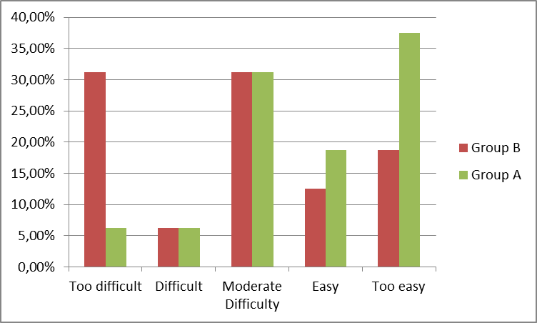

Fig. 1 shows the percentage of students that correctly answered the items of each activity. Adopting appropriate listening material is a very important goal. David and Wilson (2000) states that students will not be motivated by listening texts at the wrong level, the chosen tasks will depend on teachers’ experience with the students. For this reason, as a researcher I decided to provide a table graph of students’ performance in terms of difficulty level evaluated in each task. The range is from 0% to 100%, from the easier the item to the harder. As for the difficulty level of the listening tasks, 56.25% of the students in Group A found the items appropriate, 37.50 % very easy, and only 6.25% difficult. This suggests two conclusions that the tasks were moderate for most of the students in terms of difficulty level, and the students had achieved in every session the objectives planned for each listening activity in order to be able to continue their learning during the instructional period. As for Group B, 50% of the students tested found the listening tasks moderate, 18.75% too easy, and 31.25% too difficult. Overall, most of the students did not have problems with the tasks therefore they were also appropriate for the group. Nevertheless, participants from Group B were lacking in perseverance, they did not bring their personal materials such as pens, notebooks, dictionaries and also they had not accomplished fulfilling all the tasks. In conclusion, my expectations showed in the figure provided important diagnostic information on what the students had learnt and Group A, which received the ICT method, had achieved the objectives in each activity based upon the judgment of competent students as to the suitability of the item for purposes of the study.

There are several reasons to explain why students from Group A improved significantly their listening skills. In order to be successful students of English language, they need to feel enthusiastic about learning or feel motivated by their teachers. This aspect is essential in order for the teacher to relate well to their students and get their attention. In fact, “effective learning in the classroom depends on teacher’s ability” (Ericksen, 1978, p. 3) which can draw students' attention and enhance their learning motivation. The use of the Internet as a tool had a great impact in the classroom, students had access to a wide range of audio-visual practical programs which allowed students to feel engaged in their process of developing listening skills. For this reason, the investigation focused on using a technological implementation that enhances students’ listening skills. Therefore, students from Group A were motivated from the beginning due to the fact that they would do some tasks in a platform on the Internet. As a result, students learnt in a different way for instance it allowed them to learn in several dimensions through interactive videos, graphic representations and audio-visual environment.

The results given by the tests applied to each group in their initial class session are presented in charts. These charts contrast the results of the scores the participants got in the pretest.
Figure 2
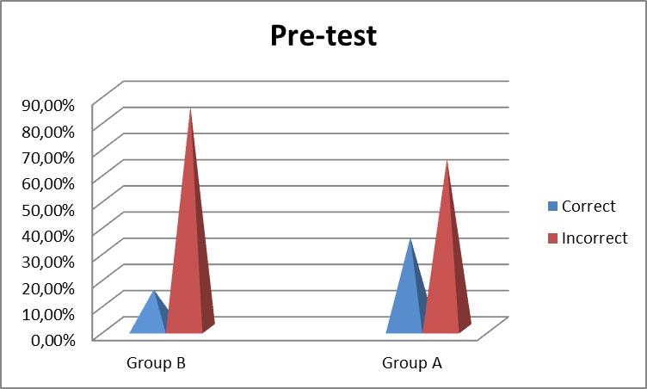

Fig. 2 reveals that students from both Groups A and B had serious problems with listening to different types of texts. As for the pre-test, it consisted of different techniques that were assessed to interpret what students had heard. These activities included listening for main ideas and listening for specific information. Therefore, the chart reported that students from Group A could not immediately recall meanings of familiar-sounding words; 65% expressed difficulties in understanding specific information and main ideas, and 85% of the students from Group B had the same issue. These problems are primarily derived from the different reasons mentioned below:
- A possible reason is that students have insufficient practice or exposure to English acoustic input in their classes so they were given limited exposure to the L2.
- They try to understand every single word or phrase and they do not relax enough to understand the main message.
- Another reason is students have not got previous knowledge in listening comprehension so the speed of the speakers is different from the listeners’ speed so the learners feel frustrated because they cannot understand and/or discriminate individual sounds, vocabulary and grammatical structures.

Therefore, the importance of prior knowledge is significant in pre-listening activities to activate and connect the information. In addition, students are unable to recognize fundamental information because they were not aware of listening strategies.

The following chart presents the scores the participants achieved in the final test.
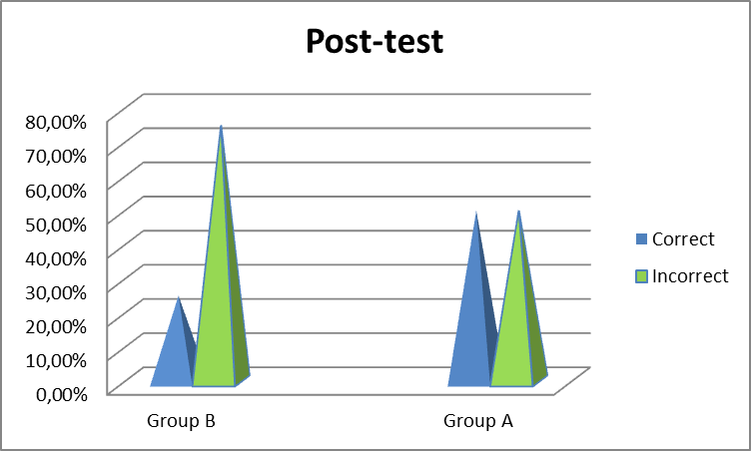
Figure 3

The quantitative analysis demonstrates considerable progress in Group A; reaching 50% in the correct answers while in Group B there was an improvement of 25%. It is clear that the students’ performance improved due to their being prepared and trained during the class sessions. However, it is important to make reference that the students who were immersed in the Internet platform actually made a significant improvement this meant that the activities given were more effective to enhance their listening comprehension. During the process, the group who were given the ICT resource had improved their scores in the two tests. According to the results obtained in the pre-test, 35% of the students from Group A were graded with a fair score. Thereupon, however, 50% of the students obtained positive results in the post-test. Subsequently, there was an increase of 15% between the initial test and the final test in Group A. If we compare these results from the pre-test to the post-test we can conclude the effectiveness of implementing a different methodology based on the use of Google Plus as part of the class the participants improved their scores significantly reducing their incorrect answers and raising the correct ones, in contrast to the other group who received the traditional methodology the students raised their correct answers from 15% (pre-test) to 25% (post-test). Finally, we can suggest that the Group B did not achieve the objectives and they had not solved their listening problems.

To identify the most useful resource for developing and improving listening skills, we need to compare the general results obtained in the tests. There was a clear improvement of 15% in Group A between the pre-test and post-test compared to Group B in which their participants improved 10% in the tests. That is to say, there is a 5% improvement divergence if we compare the two groups in question. Nevertheless, the difference between the two groups is not significant it is crucial to bear in mind the factors that the students had to deal when they had to take an exam. In fact, the results obtained in Group A performance were 30% better than Group B. The next section we will explain the reasons and show some graphs about students’ performance in both Groups A and B.
The results provided by the tests were analyzed as follows: First, in order to provide data delivered by the students’ performance during the pre/post-tests, all the percentages were calculated according to the correct answers. They were organized in a table (Table 1) in order to show in details those students who improved over the course (I), those who did not have any progress (N), and finally students who obtained the same results in the tests (S). When, we look at the results of each group separately, we see that Group A had better results compared to Group B.

Table 1 shows five students from Group A, their results remain the same in the pre/post-tests while in Group B six participants were in the same situation. As far as a good performance, the analysis below presents a considerable progress: in Group A, 15 students out of 20 had improved their results in comparison with the amount of students from Group B who demonstrated an improvement (nine students).

Eventually, there is a mathematical evidence that 5 students from Group B did not make any progress over the course as long as in Group A there were no students in that circumstance. Analyzing these facts in detail, it can be stated that the group who were under the experiment demonstrate a significant improvement during the class-sessions. In spite of the scores obtained in the tests it is important to bear in mind both aspects: first, the majority of the students from Group A had improved their results, and second the rest of the group did not have difficulty in maintaining their performance. The results provide support for the aim of this study, there is any case of a student in Group A who did not make progress over the course of the investigation.

Table 1
 |  |  | Student’s | progress
 | Group A |  |  | Group B
Student | Pre-test | Post-test | Improve/ Not | Pre-test | Post-test | Improve/ Not
1 | 22.7% | 40.9% | I | 36.3% | 18.1% | N
2 | 40.9% | 50.0% | I | 36.3% | 54.1% | I
3 | 72.7% | 95.4% | I | 50.0% | 54.5% | I
4 | 22.7% | 31.8% | I | 31.8% | 22.7% | N
5 | 50.0% | 68.1% | I | 22.7% | 22.7% | S
6 | 54.5% | 54.5% | S | 45.4% | 45.4% | S
7 | 63.6% | 63.6% | S | 36.3% | 31.8% | N
8 | 36.3% | 45.4% | I | 13.6% | 31.8% | I
9 | 59.1% | 68.1% | I | 63.6% | 72.7% | I
10 | 59.1% | 72.7% | I | 31.8% | 31.8% | S
11 | 40.9% | 40.9% | S | 50.0% | 36.3% | N
12 | 45.4% | 63.6% | I | 18.1% | 45.4% | I
13 | 72.7% | 83.3% | I | 40.9% | 31.8% | N
14 | 45.4% | 59.1% | I | 77.2% | 77.2% | S
15 | 13.6% | 50.0% | I | 31.8% | 36.3% | I
16 | 40.9% | 40.9% | S | 50.0% | 63.6% | I
17 | 50.0% | 50.0% | S | 40.9% | 45.4% | I
18 | 13.6% | 40.9% | I | 27.2% | 27.2% | S
19 | 59.1% | 68.1% | I | 22.7% | 59.1% | I
20 | 59.1% | 63.6% | I | 72.7% | 72.7% | S
I= Improvement N= No improvement S= Same result

8.1 Overall Analysis of the session classes Group A.

It is necessary to do a general analysis of the students’ results obtained in the tests. In the pre-test and post-test samples the ideal score to be reached was 22 marks. The percentages of correct answers obtained by the participants were calculated.
Figure 4
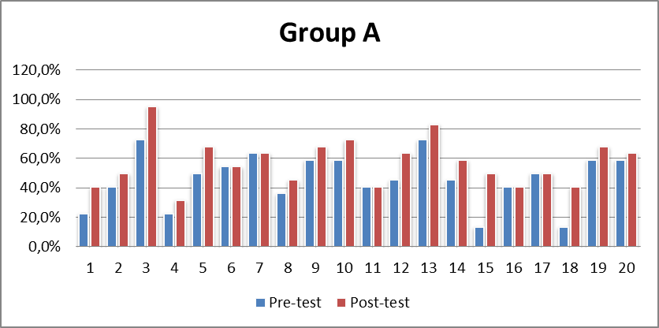

The chart demonstrates the percentage of improvement in the group per student. There was a tendency to increase the results between the pre-test and post-test respectively. Hence, it was found that students became more able to listen to different types of texts as they attempted to develop their listening skills. As it had been revealed, most of the students from Group A had made a significant improvement, as I expected in this group. Furthermore, in my opinion both groups implied progress but the fact that students from Group A were working on a platform on the Internet it turns a challenge for them because they were doing a different class with the use and help of Google which makes participants feel confident about their abilities due to it being something that they are already familiar with, and also it provides them the opportunity to work with their time without feeling the pressure they had to finish their tasks.
Figure 5
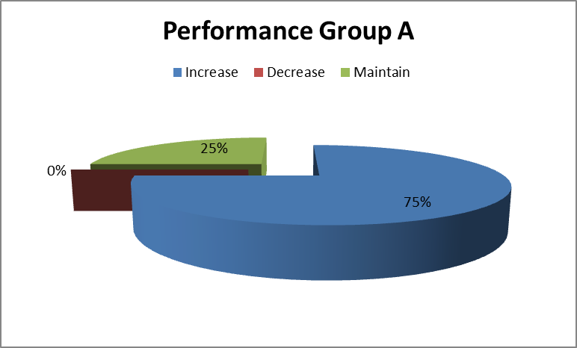

Fig. 5 states the results in percentages obtained for students’ performance in their tests. It shows that listening ability has significantly improved with a percentage of 75% of the students who got better results during the period they were working on Google platform. This finding supports the use of ICT as an effective tool to improve students’ listening comprehension where a class was implemented with creative teaching/learning activities. Only 25% of the learners maintain their results during the sessions.

It is crucial to consider the complex cognitive process in listening comprehension particularly the fast speed delivery of the text, new terminology and concepts, difficulties in concentrating, and problems related to the physical environment. Nevertheless, in my opinion these external factors were solved during their listening processes, and the students gained confidence because they overcame obstacles so it was even more challenging than working on a worksheet or textbook as they had the additional element that is the Internet despite the interruptions and other problems that we had to face.

8.2 Overall Analysis of the session classes Group B.

The following chart presents the scores the participants got in the initial test and final test.
Figure 6
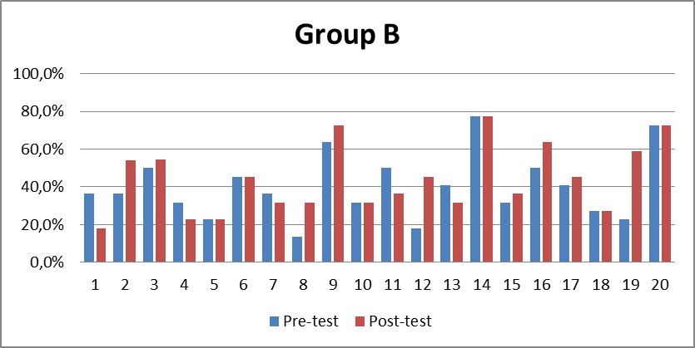

As observed in figure 6, the students from Group B were not able to improve their listening skills significantly. This chart demonstrates that students did not reach the ideal objectives in their pre- and post-tests. On one hand, it is clear that 45% of the students made progress while 30% of the cases obtain the same scores in the initial test as well as the final test. On the other hand, there were 5 students or 25% of the group who had lower marks in the final test in comparison with the pre-test therefore our students did not improve their listening skills during the sessions.
This graph represents the percentage obtained by Group B regarding students’ performance in the tests.
Figure 7
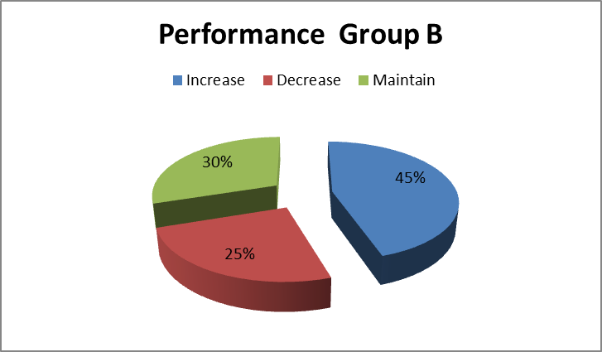

Based on numbers only, it can be clearly stated that there was a weak improvement in students’ performance from Group B in terms of their listening skills (45%) as opposed to Group A (75%), as there is a significant difference between the scores obtained. As it shown in the pie chart, only 6 from the participants or 30% maintain their performance during the sessions. There were few students who did not improve or made greater improvement and failed. In my opinion, the causes of these problems were due to the following facts, some students were not able to concentrate on the listening activities because they were easily distracted from the noise outside or because the interruptions suffered from visits made by the site supervisors. Another reason is the majority of the students did not bring their dictionaries because they forgot them or because they had several books inn their rucksacks that they preferred to leave their dictionaries at home. Finally, there were many interruptions during the process and lack of attendance in the first sessions of every week due to students’ delays, those interruptions were especially because it is a Catholic school so all the members of the school had to say a prayer at the initial time of the classes, and also in November there was a special prayer at the time when I had classes with both groups, and also because of the holidays and special days as Teachers’ Day in October.

- CONCLUSIONS

Listening is an active and essential process that facilitates the development of other language skills. The importance of this skill is perhaps the most relevant since people spend part of their waking hours listening (Lee & Hatesohl, 1993). Yet, listening in a foreign language is undeniably the most complex skill students have to encounter and one of the skills that is taught only occasionally inside the classroom due to the fact that it requires plenty of time to plan and do material selection for the class. As mentioned in the literature section, this generation has entered a new information age and it is important to give students the opportunities to be exposed to real-life contexts in order to improve their language skills, especially listening abilities. The use of ICT tools can be significant as a strategic approach to language learning by designing authentic materials that can be highly motivating to support the development of listening skills (Field, 1998). The main purpose of using Google Plus as a tool in the improvement of listening comprehension skills in the EFL class is to indicate that digitals tools could improve students’ listening skills through the participation in the target language as opposed to regular classes, by lowering levels of anxiety (Faigley, 1990; Slatin, 1991; Beauvois, 1993 and 1994; Kelm, 1992; Cononelos and Oliva, 1993; and Nicholas and Toporski, 1993).

The results of this study reveal that an interactive platform such as Google Plus was a useful tool which was integrated within a learning environment, in the 11th grade students at Piamarta School, to raise listening skills with significant effects on students assuring that this might be a feasible alternative for other EFL classes. Furthermore, the application of listening strategies was crucial to improve listening skills by using both bottom-up and top-down processing which were carried out in the different tasks to approach listening skills successfully. Guiding students to enhance listening comprehension, it was important to establish the size of acceptable item for the tasks and the difficulty level which the tasks had been designed in order to decide on one testing technique as proposed Rost (2002). Perhaps the most valuable way to test students’ performance was for teacher to compare the progress in each student at their own speed i.e. the results showed what students could do rather than merely testing them from 1 to 7, marks used in Chile to grade student’s performance. According to the results the majority of students showed that the difficulty level of listening was appropriate for them, that means students had achieved the goals proposed in each task effectively.

Regarding the results of the pre-test and post-test indicated that students from the group which were implemented the innovative digital tool obtained better scores unlike the group (B) who only received classes with the use of the worksheets. This study gauged the effects of improving listening skills by positive attitudes toward Google Plus due to students feeling motivated to work with a different approach that led to more engaged students. This means that teachers should implement innovative resources as a pedagogical tool to foster listening skills with active participation. From the findings, this study agrees with Hampel et al. (2005) that the learning context is important to influence students’ behaviour because when students are given the freedom to work at their own pace they act in a responsible manner as a consequence of using the platform of Google Plus.

As far as figures are concerned, the data presented in Figure 1 demonstrated that Group A were able to achieve the goals proposed in each class session, therefore they were improving their listening skills during the intervention opposed to Group B who may improve their performance but it was not significant as those students who used Google Pus platform to do their listening tasks. In addition, the percentages displayed in that section showed 56. 25% of the students from Group A had a positive progress in the tasks while Group B obtained 50% of the students who were able to answer the exercises correctly. This finding also indicated that for both Groups A and B the amount of tasks were suitable for them.

On the other hand, it is true that there is an improvement in the two groups as they had the same amount of tasks and the time required for the investigation was similar, it is clear that Group A progressed in their listening tasks which were a variety of activities thoroughly applied over the course.

Concerning the figures shown in the results, there is a clear and significant improvement in Group A regarding the scores obtained in the pre- and post-tests. From the findings, this study was consistent with the outcomes found to support the hypothesis stated, a significant difference was demonstrated on the pre- and post- tests since these two tests measure students’ performance in listening comprehension. The results of this investigation gave a clear answer to the research questions showing an increase of 15% of students’ progress in Group A between the initial and final tests in comparison with Group B which the percentage of students who made progress was 10%. Consequently, we can conclude that using Google Plus improved students’ listening comprehension effectively so teachers should create meaningful method in order to improve students’ language skills as the use of this digital platform which was creative and user-friendly for them.

Based on the present study, some pedagogical suggestions are presented for further research. It is recommended to assess students’ performance in listening comprehension in order to identify their weaknesses. In the EFL intervention, the first step is to provide students a period of time to create a Gmail Account. Take into account that the Internet speed is sometimes slow and it may take students long time before they can access their e-mails. Additionally, teachers need technical preparation so as to explore the interactive platform and be able to tackle all students’ questions. Hence, teachers should be able to expand their ideas and adapt new technologies in the classroom because technology promotes a cooperative learning environment despite of being time consuming in terms of instruction as opposed to that of a traditional classroom; however, there are new approaches that describe how to rebalance the time investment (see Clelia Boscolo’s comments in a case study, 2013, pp. 16-20).

Finally, the experience of conducting this study has been challenging and fulfilling. It was not easy to provide students a variety of tasks that could be appropriate for them. Moreover, it requires dedication to plan and select the materials students would use in order to obtain the expected results. Although I did expect the outcomes to be higher in terms of student’s improvement. Nevertheless, this study provides me with a rich knowledge as a teacher since I have understood the advantages of adapting new method of teaching in such a way as to integrate a digital tool to support the improvement of students’ language skill. To sum up, carrying out this investigation was an enjoyable and unforgettable experience for both my students and I.

- REFERENCES

Aliaga, M., & Gunderson, B. (2000). Interactive Statistics. Saddle River. NJ USA: Pearson Prentice-Hall.

Anderson, A., & Lynch, T. (1988). Listening. Oxford: Oxford University Press.

Asher, J. (1977). Learning Another Language Through Actions: The Complete Teacher’s Guide Book. Los Gatos, Calif. Sky Oaks Productions.

Beauvois, M. H. (1993). E-Talk: Empowering Students through Electronic Discussion in the Foreign Language Classroom. The Ram’s Horn. 7, pp. 41-47.

Córdoba, P., Coto, R. & Ramírez, M. (2005). La enseñanza del inglés en Costa Rica y la destreza auditiva en el aula desde una perspectiva histórica. Actualidades Investigativas en Educación. Retrieved November 15, 2013, From http://redalyc.uaemex.mx/pdf/447/44750205.pdf

Davis, J & Wilson, S M. (2000). Principals' efforts to empower teachers: Effects on teacher motivation and job satisfaction. Clearing House, July - August, pp. 349-353.

Dunkel, P. (1986). Developing listening fluency in L2: Theoretical principles and pedagogical considerations. The Modern Language Journal, 70, pp. 99-106.
Dunkel, P. (1991). Listening in the native and second/foreign language: Toward an integration of research and practice. TESOL Quarterly, 25, pp. 431-457.

Ericksen, S. C. (1978). The Lecture. Memo to the Faculty, no. 60. Ann Arbor: Center for Research on Teaching and Learning, University of Michigan.

Faigley, L. (1990). Subverting the electronic workbook: Teaching writing using networked computers. In Baker, D. and Monenberg, M. (Eds), The Writing Teacher as Researcher." Essays in the Theory and Practice of Class-based Research. Portsmouth, NH: Heinemann. pp. 290-312.

Field, J. (1998). Skills and Strategies: Towards a New Methodology for Listening. ELT Journal. 52 (2), pp. 110-118.

Glenn, E. (1989).A content analysis of fifty definitions of listening. Journal of the
International Listening Association, 3, pp. 21-31.

Hampel, R., Felix, U., Hauck, M. and Coleman, J. A. (2005). Complexities of learning and teaching languages in a real-time audiographic environment. German as a Foreign Language. pp. 1-30.

Harmer, J. (1998). How To Teach English. Harlow: Longman.

Harmer, J. (2001). The Practice of English Language Teaching, third edition. London. Longman.

Kelm, O. R. (1992). The Use of Synchronous Computer Networks in Second Language Acquisition: A Preliminary Report. Foreign Language Annals. 25, pp. 441-454.

Knight, P. T. (2001). Small-scale research. London: Sage Publications.

Krashen, S. (1985). The Input Hypothesis. London: Longman.

Lee, D. and Hatesohl D. (1993). Our Most Used Communication Skill. University of Missouri Extension. Retrieved December 20, 2014 http://extension.missouri.edu/p/CM150.

Levy, M. (1997). CALL: context and conceptualisation. Oxford: Oxford University Press.

Ministerio de Educación de Chile (2001). Compendio de información estadística educacional. Santiago.

Ministerio de Educación de Chile (2004). Planes y programas de Inglés tercero medio. Santiago.

Ministerio de Educación de Chile (2011). Informe de Resultados Nacionales 2° Medio SIMCE TIC. Santiago.

Ministerio de Educación de Chile (2013). Centro de Educación y Tecnología - Enlaces. Matriz de Habilidades TIC para el Aprendizaje. Santiago.

Ministerio de Educación de Chile (2014). Looking Ahead. Texto escolar segundo medio. Santiago.

Moseley, D. et al. (1999). Ways forward with ICT: effective pedagogy using information and communications technology for literacy and numeracy in primary schools. Retrieved November 12, 2013 http://www.ncl.ac.uk/ecls/research/project_ttaict/ttaict2.htm

Nicholas, M. A. and Toporski, N. (1993). Developing ‘The Critic’s Corner’: Computer Assisted Language Learning for Upper-Level Russian Students. Foreign Language Annals. 26, pp. 469-478.

Nunan, D. (1989). Designing Tasks for the Communicative Classroom. Cambridge: CUP.

Nunan, D. (1993). Introducing Discourse Analysis. London: Penguin.

Pearson K. (1900). Mathematical contributions to the theory of evolution. VII. On the correlation of characters not quantitatively measurable. Philosophical Transactions of the Royal Society Ser. A 195: pp. 1–47.

Piper A. (1986). Conversation and the computer: a study of the conversational spin-off generated among learners of English as a Foreign Language working in groups. System 14, 2: pp. 187-198.

Reid, J. (1984). Perceptual Learning Styles Preference Questionnaire. Available from J. Reid,
Department of English, University of Wyoming, Laramie, WY 82070.

Reid, M. et al. (2002). Evaluation report of Becta Digital Video Pilot Project. Coventry. Becta. Retrieved November 12, 2013 http://www.ncl.ac.uk/ecls/research/reports/digitalvideo/

Remo P, F., & Mc Glone, E. L. (1972). Understanding oral communication. Cummings Pub. Co.

Richards, J. C. (2005). Second thoughts on teaching listening. RELC Journal, 36(1), pp. 85-92.

Rost, M. (2002). Teaching and Researching Listening. Longman, Harlow.

Rozgiene, I., Medvedeva, O. & Straková, Z. (2008). EU-funded SOCRATES project ODLAC (Effective Innovative Language Learning). http://www.elearningguides.net/guides/3b-GUIDES-TUTORS-EN.pdf

Sadoux, M. (2013). Hear, there and everywhere? An Investigation into the Use of Voice Tools in the Languages Field in the UK Higher Education Sector. Report commissioned by the Higher Education Academy published online. Retrieved January 11, 2015 http://www.heacademy.ac.uk/sites/default/files/Hear_there_and_everywhere.pdf

Slatin, J. (1991). Is There a Class in This Text? Creating Knowledge in the Electronic Classroom. In: SocioMedia: Multi-Media, Hypermedia and the Social Construction of Knowledge. Edward Barrett (Ed). MIT Press. pp. 27-51.

Teeler, D and Gray, P (2000). How to Use the Internet in ELT. Harlow: Pearson Education.

Ur, P. (1984). Teaching listening comprehension. Cambridge, NY: Cambridge University Press.

Vandergrift, L. (2007). Recent developments in second and foreign language listening comprehension research. Language Teaching, 40, pp. 191-210.

Warschauer, M. (1997). Computer-mediated collaborative learning: Theory and practice. Modern Language Journal, 81(4), 470-481. doi:10.2307/328890

Warschauer, M. (1999). Electronic literacies: Language, culture, and power in online education. Mahwah, NJ: Lawrence Erlbaum Associates.

APPENDIX A
Listening Comprehension Rubric
Name: | Lesson: |  | Date:
Skills |  |  | Criteria |  |  | Points
 | 1 | 2 | 3 | 4 | 5
Understanding key events or facts. | Understands  one or two  events. | Understand two or more events and key words. | Understands  some of the  events or key  facts. | Understands  many events or  key facts,  mainly in  sequence. | Understands  most events in  sequence or  understands  most key facts.
Understanding details. | Gets no  Important details. | Gets few  important  details. | Gets some  important  details. | Gets many  important  details. | Gets most  important details  and key  language.
Responding appropriately to features such as:  laughter, silence, etc., and / or accentuation,  intonation, and rhythm. | Nearly never. | Occassionally. | Normally. | Most of the  Time. | Nearly always.
Answering questions. | Answers  questions with  incorrect  information. | Answers  questions with  some  misinterpretation. | Answers some question with literal interpretation. (short answers) | Answers  questions with  literal  interpretation. | Answers  questions with  interpretation  showing higher  level thinking.
Doing tasks. | Provides limited  or no response  and requires  many  questions or  prompts. | Provides some  response and requires some  questions and  prompts. | Provides some  response to four  or five  questions and  prompts. | Provides  adequate  response to two  or three  questions and  prompts. | Provides  insightful  response to one  or no questions  or prompts..
At the end of the session, the listener is able to: | Answer factual  questions on  general  information. | Answer factual  questions on  general and  specific  information. | Summarise the  beginning or  The end  of the story. | Summarise the  beginning,  middle, and end  of the story. | Reveal the  sequence of  events, providing  details on  dialogue and  motivation of  characters.
 |  |  |  |  | Total Points
APPENDIX B
Listening pre- and post-tests
ENGLISH TEST
NAME: ________________________________________________________ CLASS:________________________

- Location. First, study the map. Then, listen to the conversation and answer the questions.
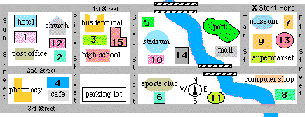
1. When is Steve going out with Jennifer?
A. Friday
B. Saturday
C. Sunday
- Monday

2. Where is the movie theater?
A. 2
B. 1
C. 12
D. 4
3. Where is the restaurant located?
A. 6
B. 11
C. 14
D. 8
4. What time does the restaurant close on Sundays?
A. 10:30 PM
B. 11: 00 PM
C. 11:30 PM
D. 12:00 AM

5. Where is the florist?
A. 10
B. 6
C. 15
D. 5

II. Places in Town.

- Where does Rebecca go during the week while her husband works?
a) church
- supermarket
- home
- bank

2) Where does Rebecca go to buy food?
- the supermarket
- the bank
- home
- park

3) Where does Rebecca go to exercise?
- the movie theater
- the gym
- a friend's house
- church

4) If the weather is nice Rebecca exercises at the:
- gym
- house
- her yard
d) park

5) Where are Rebecca and her husband going this weekend?
- a restaurant
- movie theater
- home
d) church

6) Why do they come home early on Saturday night?
- for work on Sunday
- for school on Sunday
- for church on Sunday
- they don't come home early

- Do Rebecca's kids go to school?
a) yes
b) no
c) maybe
d) she doesn't say

III. Book a hotel.
A) Listen to a conversation and answer the questions.

1. The man makes a reservation finally for which day?
A. March 20th
B. March 21st
C. March 22nd

2. What kind of room does the man prefer?
A. a non-smoking room
B. a smoking room
C. either one is okay
3. Why doesn't he want to reserve the suite?
A. It doesn't have a nice view.
B. It doesn't come with a sauna bath.
C. It's too expensive.
4. Including tax, how much is the man's room?
A. 80 dollars
B. 88 dollars
C. 96 dollars
5. How do you spell the man's name?
A. Maxner
B. Maexner
C. Mexner
B) You will hear a lady speaking on the telephone. She wants some information about a hotel. Listen and complete the questions.
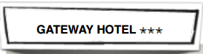
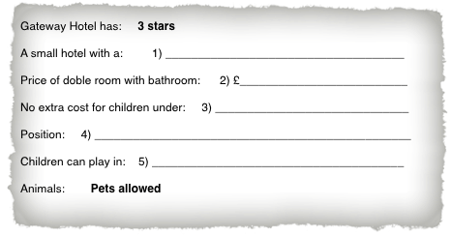

Table showing the difficulty level of the tasks in both Groups A and B

Difficulty Level Group A
Less than 40% | 6,25%
Between 41 % and 50% | 6,25%
Between 51% and 80% | 31,25%
Between 81% and 90% | 18,75%
Between 91 and 100% | 37,50%

Difficulty Level Group B
Too difficult | 31,25%
Difficult | 6,25%
Moderate Difficulty | 31,25%
Easy | 12,50%
Too easy | 18,75%

APPENDIX D
Table showing students’ performance in the pre-test
 | Correct | Incorrect
Group B | 15,00% | 85,00%
Group A | 35,00% | 65,00%

Table showing students’ performance in the post-test

 | Correct | Incorrect
Group B | 25,00% | 75,00%
Group A | 50,00% | 50,00%

APPENDIX E

Table showing a comparison of students’ progress in the pre- and post- tests.

 | Group A | Group A
Increase | 45% | 75%
Decrease | 25% | 0%
Maintain | 30% | 25%

APPENDIX F
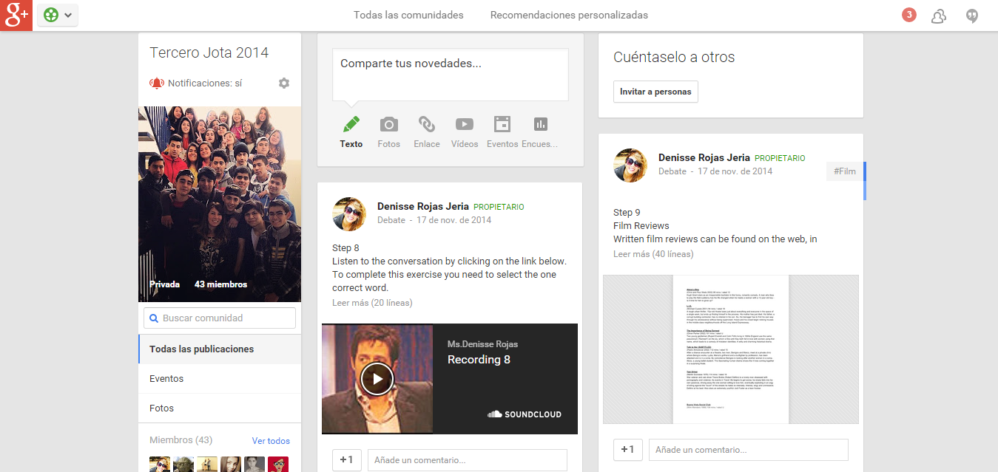
Google Plus platform: Class Community
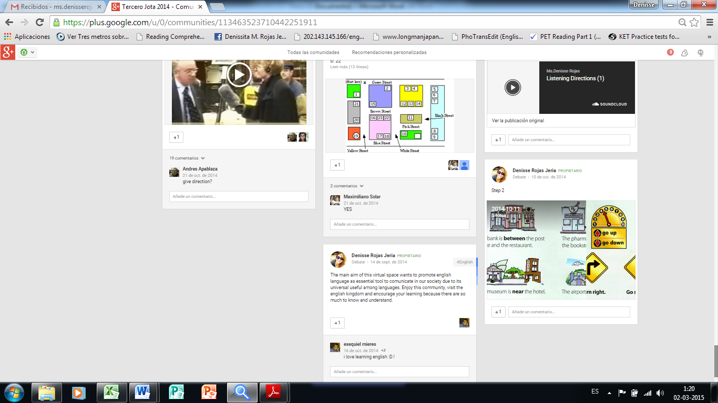

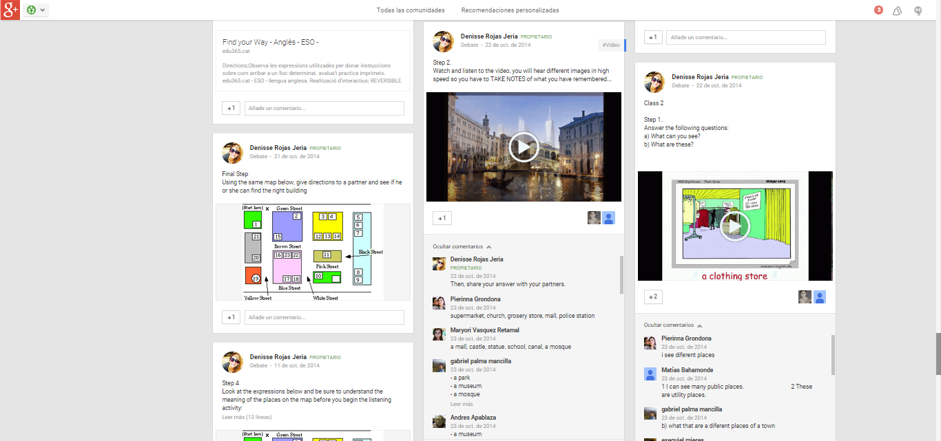
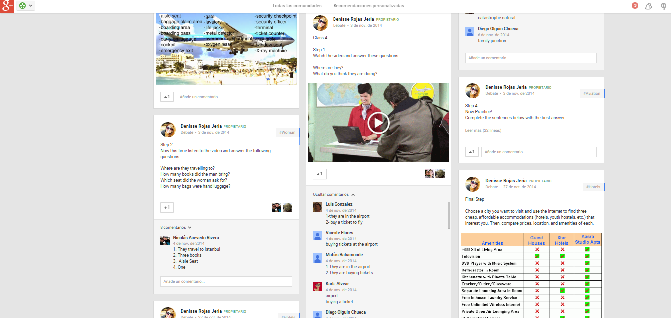

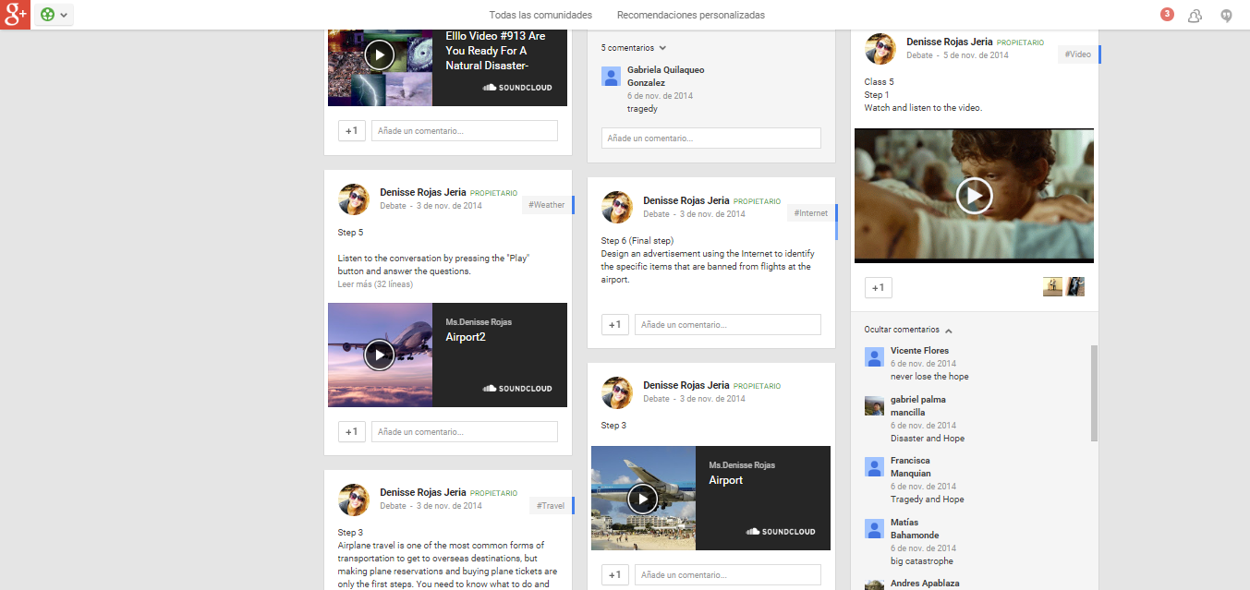
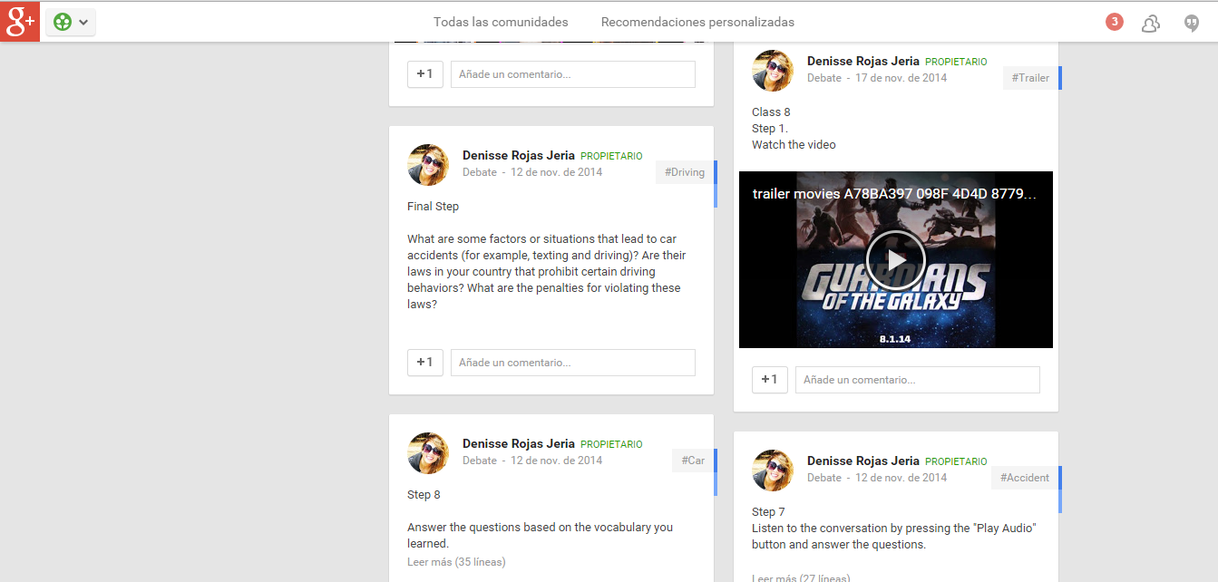

APPENDIX G
Lesson plans Group A

Module 1: “Directions”

Aims: Give students listening practice to listen to a conversation, and be able to give and ask for directions using key words.

Length of lesson: 90 minutes

Listening Strategy:

- Listening to a conversation
- Predicting
- Working with grids
- Answering questions
- Locating specific information

Materials: radio, CD, worksheets, markers and eraser.

Assumptions: students may be familiar with some of the vocabulary.

Stages

- Warm up: Teacher asks students to register their username and password to an account in Google Apps. They sign in with their Gmails accounts and then, they will find the class account this manner they can watch, read, write and listen to different videos that will be exposed during the sessions. Students will see a video shared by the class account.

- Pre-listening: The teacher tells students they will play a video and that they will have to identify what the lesson is going to be about. Teacher informs students that they will need to take notes in order to remember the content of the video. The teacher informs students that this video will help them to practice the key vocabulary words and phrases needed for certain tasks. Students must briefly introduce the topic.

- Listening: Students’ attention is attracted via the short video in order to introduce them to the theme and vocabulary bank. Students note down as many prepositions they can hear and/or recall as possible. Teacher elicits responses through peer interaction (definitions are given in the L1). With the help of some pictures from the website Google, students practice certain prepositions of places. Students watch a short video and pay attention to the way language is used. Focus of attention is to help them become familiar with standard formulas used when asking for and giving directions. They are given the opportunity to see the language in real action and benefit from developing their direction and location skills.

- Post-listening: Students are asked to draw a street map where they select and highlight several locations as reference points to be used in the activity assigned for homework.

- Evaluation: Based on their sample map they are asked to write down 1 short dialogue where A asks for directions and B gives directions. These directions can also be practised orally in a role play, with student A giving directions from the map and student B tracing the path onto a blank version of the same map.

- Rounding-off: The teacher summarises all the taught prepositions with the help of the power point slides 5 to 8 – which are also distributed to the students to provide them with the opportunity of review at home.

Module 2: “The Town”

Aims: Foster students’ listening and speaking skills in the EFL classroom by identifying features in a town landscape.

Length of lesson: 90 minutes

Listening Strategy:
- Listening to a recording
- Predicting
- Gap-filling tasks
- Answering questions
- Locating specific information

Materials: You-tube videos, computers, headphones.

Assumptions: Students will be unfamiliar with the pronunciation of some words.

Stages

- Warm up: The teacher introduces the topic by asking the students to go to the Google platform and see a set of pictures asking questions e.g. what’s this?

- Pre-listening: Students are invited to watch and listen to a video in which they will hear different places in high speed so they have to take notes of why they heard. Then, they will share and compare their answers with their peers in Google platform.

- Listening: Students will be asked to identify features in a town landscape derived from a web-page. Students will click on the button and they will see a map, they will have to search five spies that are hiding in a town, they have to follow instructions.

- Post-listening: Students will answer a set of questions published in the platform in order to check their understanding on listening to the features appear in the activity before. While listening to the video students will carry out a relevant gap-filling task.

- Evaluation: Teacher will give the students the task of designing a town map in Paint program and then they will have to upload to the platform in order to receive feedback from their peers.

- Rounding-off: in order to get a lesson feedback as well.

Module 3: “Booking a Hotel”

Aims: Give students practice vocabulary related to hotels/accommodation. Students will be able to practice listening by watching. Students will practise speaking skills by asking and answering questions at a hotel reception.

Length of lesson: 90 minutes

Listening Strategy:
- Listening to a video
- Working with grids
- Answering questions
- Locating general and specific information

Materials: You-tube videos, computers, headphones.

Assumptions: Students may be familiar with most of vocabulary.

Stages

- Warm up: The teacher introduces the topic by brainstorming various types of hotels/accommodation, and also asks students to write down all the suggested words on their material using the platform.

- Pre-listening: The teacher introduces the next topic by asking students to find synonyms to the words given. Students record the synonyms and make a complete definition for each word using the prompts. The definition will be checked by using the platform. Then the teacher sets a scene by brainstorming questions and asks students to compare and record their own ideas with the words and expressions given. The teacher sets a scene for the next activity by providing a video with different types of hotels appear.

- Listening: The students will be asked to watch and listen to a variety of accommodations that hotels might include then do comprehension exercises. Answer questions about the text and fill in the gap exercises.

- Post - Listening: The teacher tells students to imagine that they are traveling abroad for summer vacation, and they have three cities in mind: Paris, New York City, and Tokyo. Students use different resources to find more information about the cities. Then, they compare the accommodations based on price, amenities, location and make a recommendation to a partner.

- Evaluation: Students will have to upload their task on the platform by choosing one hotel what they have recommended. The teacher provides all the necessary feedback when they have submitted the task.

- Rounding off: The teacher asks students “What have you learnt today?” students answer aloud and comment.
Module 4: “At the Airport”

Aims: Students will be able to understand a short dialogue, and to talk about airport information.

Length of lesson: 90 minutes

Listening Strategy:

- Listening to a dialogue
- Predicting
- Working with grids
- Answering questions
- Locating general and specific information
- Discriminating some words
- Acting short guided dialogues

Materials: You-tube videos, computers, headphones.

Assumptions: Students may be familiar with most of vocabulary.

Stages

- Warm up: The teacher projects a video without audio and asks students to describe what they see.

- Pre- Listening: The teacher asks students to answer some questions online about the video, and then they have to look up some vocabulary appear on the platform in bold. Next, students have to order the sequence of pictures they remember from the video.

- Listening: Teacher asks students to watch the video again but this time the audio will be included in order to confirm their predictions. Then, students will answer some questions about the video.

- Post- listening: Students will answer the following questions online “What are some of your frustrations when going through an airport? Is there anything you can do personally to minimize these problems? What can airports do to deal with these issues?” The teacher asks students to design an advertisement using the Internet to identify the specific items that are banned from flights at the airport.

- Evaluation: Students show their work summarising their findings and give a reason why each item is banned from flights.

- Rounding off: Teacher asks students “What have you learned today?” students comment about the topic leaned online.

APPENDIX H
Lesson plans Group B
Module 1: “Directions”

Aims: Give students listening practice to listen to a conversation, and be able to give and ask for directions using key words.

Length of lesson: 90 minutes

Listening Strategy:
- Listening to a conversation
- Predicting
- Working with grids
- Answering questions
- Locating specific information

Materials: radio, CD, worksheets, markers and eraser.

Assumptions: students may be familiar with some of the vocabulary.

Stages

- Warm up: the teacher will give each student a worksheet with some questions in which students will work in pairs. They will interact with the questions and then they will compare their answers with other classmates.

- Pre-listening: The teacher asks students to see the picture in their worksheet which appears a map of the school. The teacher asks students the following questions: What can you see? What is the address of the school? Then the teacher will write on the board the headline of the conversation of what they will hear “How do I get to the train station”. Students will predict what the conversation is about.

- Listening: the teacher asks students to listen to a conversation and do some comprehension exercises. Answer questions and fill in the spaces with the information appears in the listening.

- Post-listening: the teacher asks students to work by their own to fill in the gaps the names of the places and people using the vocabulary heard in the conversation in order to complete the information in the worksheet.

- Evaluation: the students will work in small groups and they will make some suggestions about the places where they can go. Students will ask and answer questions such as: Where can I buy some aspirins? where can I send letters?, etc.

- Rounding-off: the teacher will do a final review of the lesson.
Module 2: “The Town”

Aims: Foster students’ listening and speaking skills in the EFL classroom by identifying features in a town landscape.

Length of lesson: 90 minutes

Listening Strategy:

- Listening to a recording
- Predicting
- Gap-filling task
- Answering questions
- Locating specific information

Materials: radio, CD, worksheets, markers and eraser.

Assumptions: Students will be unfamiliar with the pronunciation of some words.

Stages

- Warm up: The teacher introduces the topic by showing some pictures of different places from a town and asking questions e.g. what’s this? Have you ever needed it? Why do we usually need it?

- Pre-listening: Students are asked to make guesses about the purpose of the lesson, e.g. what are we going to talk about today? Students are invited to listen to a dialogue in which two interlocutors are talking about places.

- Listening: The teacher asks students to listen to the recording and work in pairs with two maps. The idea of this task is information gap. Each learner gets a handout with different places marked on the map. The students’ job is to exchange information in order to complete their maps.

- Post-listening: the teacher asks students to work by their own to put the sentences in order according to the pictures. They will also answer True/False questions.

- Evaluation: In pairs students will plan a town landscape describing the features in a town landscape (supermarket, house, hotel, multi-storey, etc). They will expose their maps in front of the class explaining their contents.

- Rounding-off: the teacher will do a final review of the lesson.

Module 3: “Booking a hotel”

Aims: Give students the skills to enter a hotel and book a room.

Length of lesson: 90 minutes

Listening Strategy:

- Listening to a conversation
- Predicting
- Working with grids
- Answering questions
- Locating general and specific information
- Discriminating some words

Materials: radio, CD, worksheets, markers and eraser.

Assumptions: Students may be familiar with most of vocabulary.

Stages

- Warm up: The teacher passes out the mixed-up conversation and has the students work in pairs (or groups). After they have finished, the teacher goes over the conversation as a class.

- Pre-listening: The teacher looks at the conversation as a class and discuss a few of the patterns. The teacher tries to highlight the difference between asking for something politely and just simply grunting out needs. A few students try to book a room from their classmates. Then the teacher compares what they say with the original conversation.

- Listening: The students will be asked to listen to a conversation and then do comprehension exercises. Answer questions about the text and they will match vocabulary with their synonyms.

- Post- listening: The teacher asks students to work in pairs a role-play activity to practice booking a room in a HOTEL. Student A will be a hotel front desk clerk and student B will be a hotel guest. The front desk clerks get hotel information cards and a front desk activity sheet, which they have to fill out. The guests get their role-play prompts and their activity sheets, which they have to fill out. The guests will go from hotel to hotel and BOOK a room in each hotel. As the guests are going around, both guests and front desk clerks are recording information.

- Evaluation: The teacher will choose some groups to perform the activity in front of the class.

- Rounding off: The teacher asks students “What have you learnt today?” students answer aloud and comment.

Module 4: “At the Airport”

Aims: Students will be able to understand a short dialogue, and to talk about airport English.

Length of lesson: 90 minutes

Listening Strategy:
- Listening to a dialogue
- Predicting
- Working with grids
- Answering questions
- Locating general and specific information
- Acting short guided dialogues

Materials: radio, CD, worksheets, markers and eraser.

Assumptions: Students may be familiar with most of vocabulary.

Stages

- Warm up: The Teacher will give each student a role-play sheet. There are two versions of the customs officer role-play sheet, A and B. This is so that students can hear common customs questions asked in more than one way. The teacher tells the students that they will be studying airport English. One student will come up to the front, the teacher gives that student a passport card and the student will have to pass customs. Because the teacher is the customs officer who will be able to lead the conversation.

- Pre- Listening: After a few students have tried to get through the teacher’s customs and immigration, then the teacher goes over a conversation. The teacher writes the questions on the board and asks the students what possible answers could be. With all of the questions and possible answers on the board, few more students will try to come through the customs.

- Listening: Teacher asks students to listen to a conversation about taking a plane and go to the airport. Answer true or false and complete sentences with information about the text.

- Post- listening: Students will work in pairs. Students A will be customs officers and students B will be travelers. The teacher hands out the custom officer role-play sheet to the custom officers. Each custom officer represents a country of their choosing and they will briefly interview each traveler before letting them into the country. The teacher will put the students’ desks in a line so that the travelers can go from one customs officer to another in an orderly fashion.

- Evaluation: At the end of the lass, some groups presents in front of the class their comments about their travelers' information.

- Rounding off: The teacher will do a final review of the lesson.

Term that is often associated with Stephen Krashen’s input hypothesis (1982).
Defined as input + 1, input is the current knowledge of a learner and 1 for the next stage. Therefore, the learner improves along the 'natural order' when they receive second language 'input'that is one step beyond their current level of linguistic competence (1985).
Educared recommendations is an online blog designed to deliver information, suggestions and curiosities with other social networks about new ICTs regarding education methodologies. (2011)
Also known as Google+ or G+ (created in 2011)
They are operating systems used primarily in mobile technology
This is designed to serve as the fundamental resource for information on the scope of the admissions process to higher education.
It is a 10th grade textbook designed by the Ministry of Education of Chile.
*The Pearson r method is commonly used measure of correlation between two variables X and Y, giving a value between +1 and −1 inclusive, where 1 is total positive correlation, 0 is no correlation, and −1 is total negative correlation (1900).

